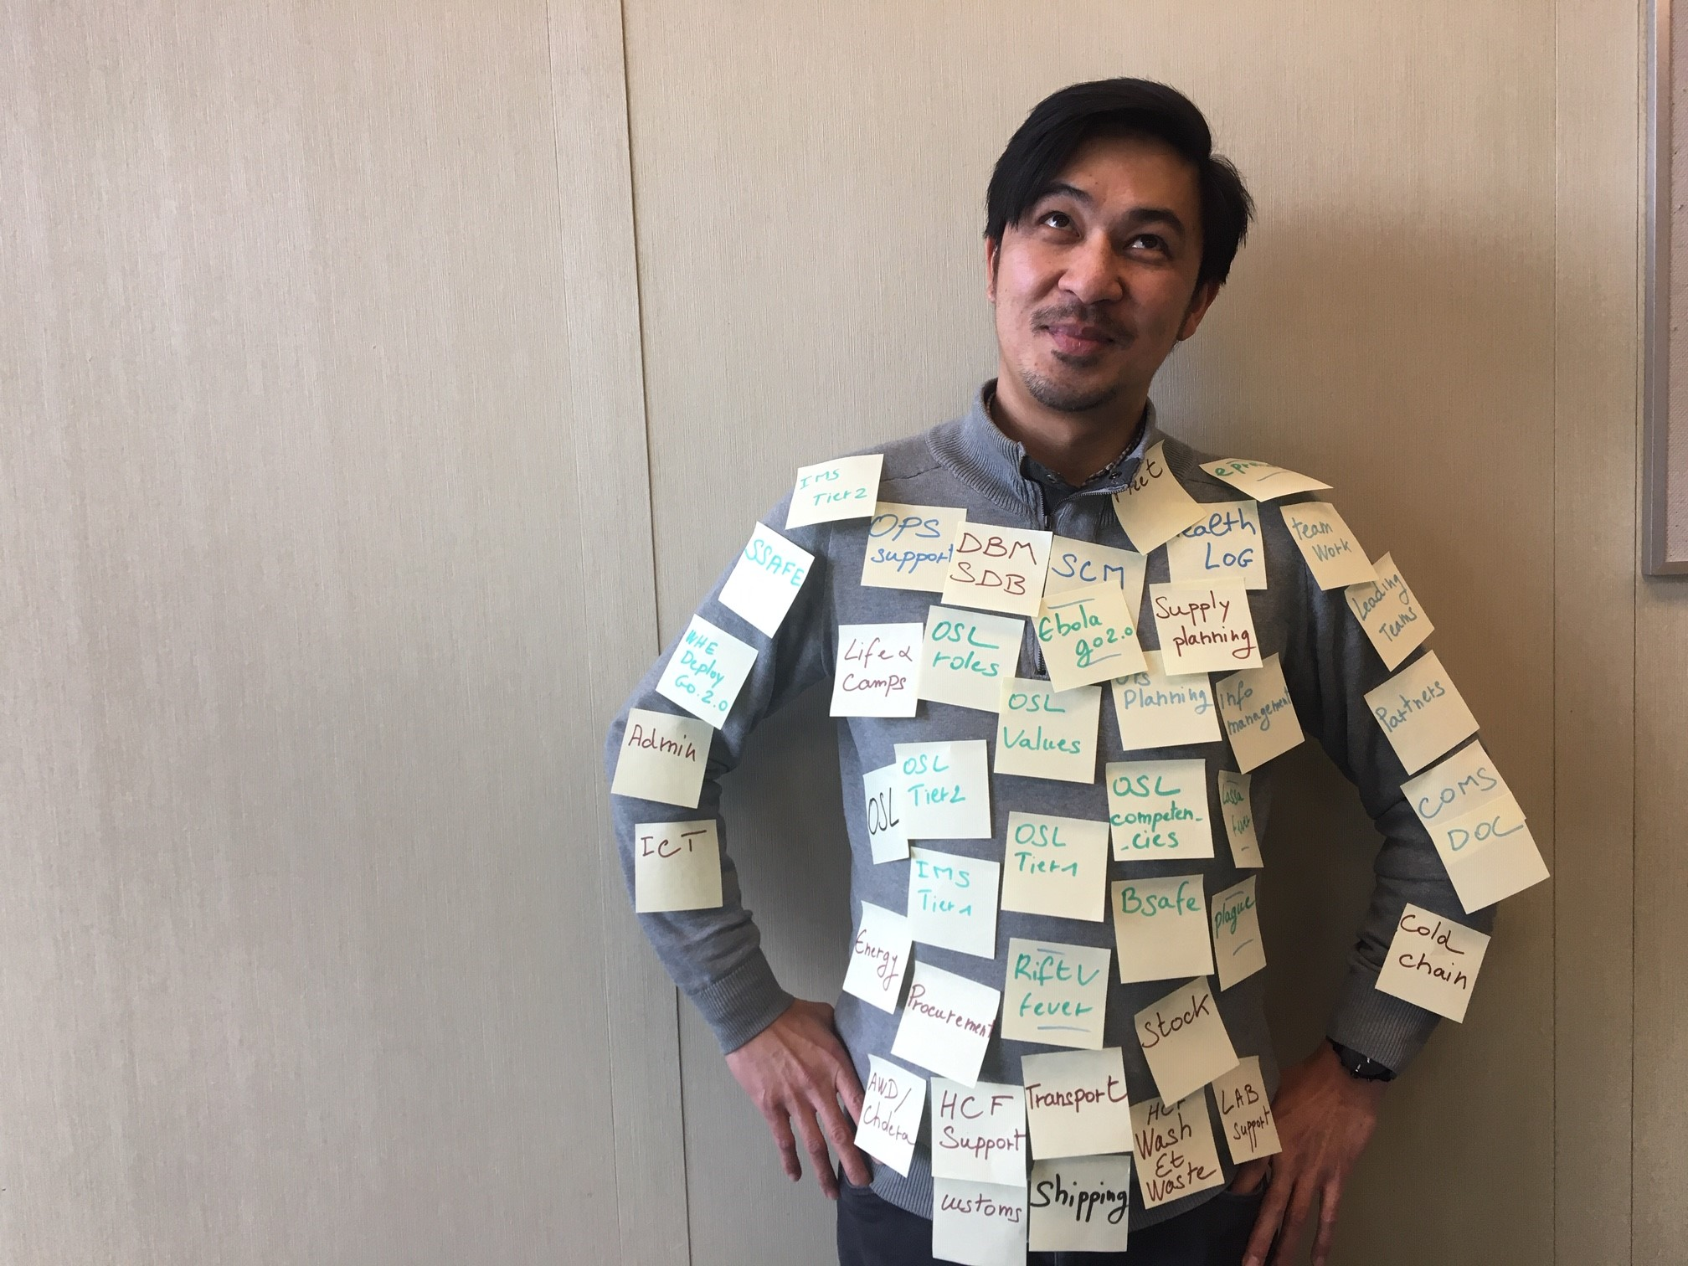
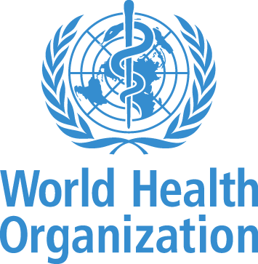
Feb 2020
Operation Support and Logistics

LEARNING AND DEVELOPMENT STRATEGY
The information contained in this document are constantly evolving and so is the OSL Learning and Development Strategyto reflect user feedback, latest lessons learned and improvements to Health Emergencies activities, practices and learning materials

CONTENT

EXECUTIVE SUMMARY
A. OSL LEARNING & DEVELOPMENT STRATEGY
A.1 Background and Context
A.1.1 Why Does OSL Need a Learning and Development Strategy?
A.1,2 An Aligned Approach
A.1.3 A competency-based approach for OSL Learning and development
A.2 Foundations of the Strategy
A.2.1 What is the Strategy Built Upon?
A.2.2 Standards
A.2.3 Principles
A.3.Target Audiences
A.3.1 Who is this Strategy Written For?
A.3.2 Who is OSL in 2019?
A.3.2 OSL Training Audiences
A.4 Pragmatic Approach to OSL Learning
A.4.1 What OSL Will Do Through Outcomes, Outputs and Enabling Actions
A.4.2 How OSL Will Do It
ANNEX B. COMPETENCY FRAMEWORK FOR OSL
ANNEX C. OSL LEARNING CURRICULA MAPPING
ANNEX D. OSL LEARNING PATHWAYS
ANNEX E. IMPLEMENTATION PLAN
ANNEX F. SUMMARY OF WHE COMPETENCIES & BEHAVIORAL INDICATORS
ANNEX G. 2020 OSL TRAINING NEEDS AND PLANS

Executive Summary

Operations Support and Logistics (OSL) takes a pragmatic approach to learning and development at headquarters, regional and country office levels, and in working with its partners. A comprehensive and relevant system of learning resources nurtures an able, motivated and diversified workforce for OSL’s future work in health emergencies.

As WHO moves forward, transforming and evolving at an organizational level with its learning strategies for all health emergencies personnel, the OSL approach to learning ensures the promotion of a distinctive WHO OSL ethos & culture. WHO OSL uses WHE behavioural competencies and channels them to focus directly on the needs of the OSL community it relies upon. This community connects OSL internal and external personnel and partners. Learning initiatives are linked together to encourage opportunities for nurturing and exchange amongst each other while expecting in turn those people, who want to be part of WHO OSL network and roster to make a commitment to WHO. For learning to fulfil its effectiveness in the workplace, managers actively support and give responsibility to individuals in putting new knowledge and skills into practice. Following through in this way will strengthen the ways in which learning leads to impactful changes for people in need.

In practical terms, the strategy outlines two main outcomes, each comprising several outputs.

The first outcome is for OSL staff and roster members to have access to quality learning throughout their career pathways.

OSL will promote diversity, localisation and mobilityin selecting participants for learning initiatives so that staff and consultants are empowered to go where they are needed and want to be, to switch roles where useful, and to progress their careers within OSL and the wider WHO structures. Proactively ensuring newly recruited OSL personnel have places on foundation level learnings is an important step towards achieving a collective understanding of current organizational approaches to emergency response and in country roles of OSL. As OSL network members gain greater experience, further relevant opportunities are identified to enhance and develop their skills.

In line with industry standards, a variety of progressive learning methodologies will be used across OSL formal learning. Training workshops offer dedicated time to explore and reflect on subjects in the company of peers and subject matter experts. Interactive online modules form part of the learning portfolio to develop technical competencies further. Given the close collaboration with other Incident Management Team (IMT) pillars, the scope for simulations, tabletop exercises and case studies is also important for examining the application of OSL activities in context.

Development of training syllabi will be coordinated to ensure all technical elements are included in amounts that are consistent and appropriate for each training audience, as guided by the OSL competency framework. Training solutions will be evaluated using pragmatic tools designed to increase the relevance and effectiveness of OSL training interventions over a period of time.

The second major outcome of the strategy outlines an opportunistic, yet systemic, approach towards building a better understanding of OSL amongst other key partners.

Through an appreciation of what OSL personnel do and how, WHE roster members, other pillars of IMT and national partners will attach greater importance to supporting an enabling environment within which OSL can thrive. To achieve this, proactive and targeted knowledge sharing is required by OSL network to interact and engage with its internal and external partners.

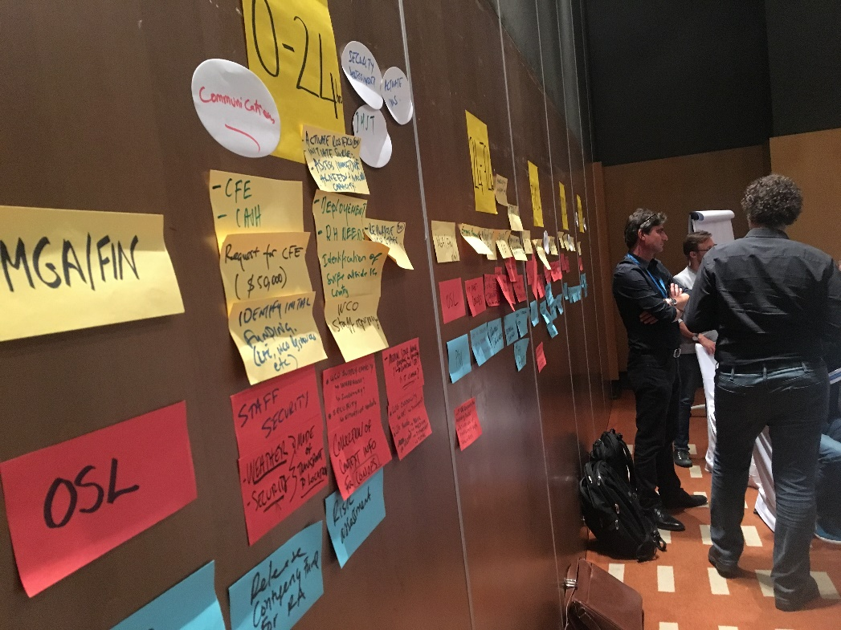

A.1 Background & Context

A.1.1 Why Does OSL Need a Learning and Development Strategy?

Operation Support and Logistics (OSL) is a key component of the World Health Organization’s Health in Emergencies (WHE) programme. Rather than resting purely as a source of technical expertise, this programme supplements WHO towards an operational mindset as an integral cornerstone of its all-hazard approach to emergency management.

The environment in which WHO operates is constantly evolving. Hence, in 2016 the move to institute the health in emergencies approach. Each new operation in which this approach is applied learns from, and builds upon, the previous ones with new insights.

A.1.2 An Aligned OSL approach

OSL has mapped the technical and functional expertise it requires at all three levels of the organization - headquarters, regional and country. This allows management to ensure the appropriate capacity, in terms of quality and quantity is in place as the organization transforms.

Further, it encourages learning pathways to be determined for personnel and supervisors to plot individual career development, relevant to the circumstances and needs of WHO shaped by WHO Transformationto produce timely, meaningful, concrete improvements.

A.1 BACKGROUND AND CONTEXT
OSL, through the current learning and development strategy, is adapting the ways and means its personnel are working

Relationships within the humanitarian environment are taking on more prominence. The values of the OSL workforce furthermore reflect the principles of human rights, universality and equity established in WHO’s Constitution as well as the ethical standards of the Organization expressed in WHO Values charter. The complexity is becoming more nuanced as a wider diversity of national and international actors and interests become involved in field operations. National and local authorities are demanding a greater respect for their capacities and control of what happens, and how, within their territories. Humanitarian principles such as the “Localization” commitment of the largest donors and humanitarian organizations through the GRAND BARGAIN agreement, has brought a new dimension to the meaning of effectiveness and efficiency of field operations.

In previous years, the primary learning need identified was to recruit and train the OSL personnel deployed during acute health events to perform a logistics function and support operations.

Today Being fit-for-purpose brings a different meaning; one that goes beyond simply technical competence. Engaging positively with diverse stakeholders, while building capacity upon request and in the manner appropriate amongst international and local partners, is a fundamental part of how the job needs to be done.

Equally, and as evidenced by the Emergency Response Framework (ERF), building cross-cutting relations for a predictable, coordinated response by WHO in its Incident Management System (IMS) must be embedded. This translates into a new set of competencies expected of WHE as it interacts with partners and humanitarian organizations. The ERF, therefore, raises challenges for the approach to learning within OSL, and its partners in the humanitarian and acute health emergency context.

This OSL Learning and Development Strategy sets out the vision and objectives for OSL to be a positively-minded component of WHE during acute health events, based upon having a fit-for-purpose workforce which embodies this philosophy. The OSL strategy complements the overarching WHE Learning Strategy, adopted in late 2018, applying a culture of learning specifically to those working within OSL, and demystifying the learning landscape for its partners.

A.1.3 A competency-based approach to OSL Learning and development

The strategy embraces a competency-based approach to OSL learning by interpreting the behavioural WHO and WHE competencies in a manner that speaks directly to OSL staff, consultants and roster-based personnel. It applies the most relevant competencies to what they do (technical excellence) and, equally importantly, to how they work (behavioural excellence) with colleagues and partners. Priority competencies and behavioral indicators are then linked to learning content and mapped to learning and development pathways for OSL personnel.

The process that OSL has gone through to develop this learning strategy is every bit as important as the written document.

This is the first time OSL has systematically reached within and outside itself to identify what - related to learning - is working well, what can be modified and what gaps might be filled with new innovations. Stakeholder engagement has suggested that the past approach to OSL learning was reactive and ad hoc; one that would benefit from a more strategic, systemic approach. In so doing, a structure and framework is proposed for how people will engage with OSL learning activities.

Review of the outcomes, outputs and enabling actions implementation of this strategy will be conducted annually, in step with how WHE evolves organizationally. It is proposed to pilot the strategy through an implementation plan during 2019 in the African and Eastern Mediterranean regions, with lessons learned and adjustments drawn from a monitoring and feedback process.

A.2 FOUNDATIONS OF THE STRATEGY

A.2 FOUNDATIONS OF THE STRATEGY

A.2.1 What is the Strategy Built Upon?

Taking the lead from the WHE learning strategy, this piece of work is purposefully named a learning and development strategy, not simply a training strategy. This challenges the traditional modality for how learning has typically been delivered within OSL i.e. formal classroom training events organized for participants to learn technical subjects. Many OSL stakeholders, however, cautioned against continuing a trend of overload through online learning modules that can encourage a click-click approach to collecting training certificates.
Therefore, by encouraging learning to be understood in its widest sense, OSL is easing aside the barriers of definition between what is formal learning through training and more informal endeavors of experience and exchange.

A.2.2 Standards

The quality standards for OSL learning and development - including materials and tools - are, naturally those adopted by the WHE Learning Strategy focusing on Adult Learning methodologies. Throughout the OSL strategy these standards guide the outputs, so that personnel understand and see how relevant they are to their work and how they wish themselves and colleagues to develop.
Formal training, together with social and experimental learning, is one vehicle for learning; the learning cycle OSL adopts has four essential steps that ensure a rigorous compliance of these standards. Embarking from i. analyzing the WHE performance challenges and training gaps, to ii. designing and planning the training, followed by iii. delivering it and the final- oft overlooked- of iv. monitoring, evaluating, and hence improving, the impact of learning and effectiveness of OSL personnel is put central.

The OSL Training Development Kit is available as a companion document to promote concretely this approach by proposing tools, templates and how-to guide, for the design at all stages of quality and high impact OSL learning materials and sessions.

A.2.3 Principles

The following table summarizes the fundamental principles of to the OSL Learning and Development strategy and of its implementation.

Training as one part of the solution | It is recognized that dedicated training products represent only one modality for learning, and that the OSL workforce can develop knowledge, skills and attitudes through informal as well as formal interactions. Organized training must be targeted at specific capability gaps for both routine and emergency contexts and seek to accelerate lifelong learning.
Linkage to institutional learning strategies | It is acknowledged that the OSL L&D Strategy is informed by an organization-wide approach to learning and development, as outlined in key corporate strategy documents.
Linkage to WHO competency framework | Training content and learning pathways are guided by the workplace skills and behaviours critical to OSL, as outlined in WHO’s competency framework requirements for managing and developing performance through the electronic Performance Management and Development System (e-PMDS).
Integration into WHO Learning Management Systems and e-PMDS | Information regarding a staff member’s progress through OSL learning pathways should be tracked, documented and made available to both the individual and his/her management chain for credentialing purposes. It should also be recorded in the staff member’s e-PMDS.
Maximum accessibility | Training products and resources should be delivered in ways that reach the greatest number of staff members possible whilst minimizing disruption to their operational roles.
Shared responsibility for training outcomes | Success of the OSL L&D Strategy will require a spirit of mutual responsibility and interdependency between the WHO and the trainee.
Emphasis on adult learning methodologies | OSL should promote a blended training approach which utilizes interactive and learner-centred delivery techniques, is relevant to practical application of subject matter, and draws on the life experiences of participants.
Expand commonalities with other UN partners | As OSL grows in maturity, opportunities should be sought to collaborate with other UN agencies and partners based on shared training needs and resources.

A.3 TARGET AUDIENCES

A.3 TARGET AUDIENCES
A. 3.1 Who is this OSL Learning and Development Strategy for?
The strategy is an articulation of how collectively WHO sees learning should be guided in the coming years, towards the aim of making and keeping OSL fit for purpose. While OSL management is naturally the guardian of the strategy, shaping how learning is rolled out as part of WHE, it is expected that through rigour and attention to quality standards the strategy will guide a more devolved approach, managed and supported by flexible OSL oversight at headquarters.

The primary intended audiences for the OSL Learning and Development Strategy are:
- WHE/EMO/OSL Emergency programme staff;
- WHO personnel (including internal rosters and networks) currently outside of WHE but who are recruited to act in an operations support and logistics role within a WHO health emergency response.
The secondary audiences that will also benefit from the OSL strategy include:
- WHO personnel involved in health emergency response (global, regional and country levels);
- WHE-affiliated global health workforce (such as candidates on WHO rosters, surge capacity, Standby Partners, networks, collaborating centres);
- National governments and their key logistics partners;
- WHE OSL partners in operations including other UN agencies, the Red Cross and Red Crescent Movement, International NGOs, and academic or research institutions.
3.2 Who is OSL in 2019?
The three pillars of OSL are:

- Logistics Operations-Field Support (OPS): Provides overarching logistics management and field support to response teams. This includes the rapid set-up of critical response infrastructure, storage, transport, delivery mechanisms and partner management. Included also is the support for establishing suitable accommodation, functional and secure working spaces, critical equipment, communications capabilities, safe staff transport and effective fleet management.

- Emergency Supply Chain Management (SCM): Ensures a timely and efficient provision of consumables and equipment to support emergency operations, in environment where WHO responsibility goes beyond the port of entry. This includes selection, forecasting, procurement, air/sea/land shipment combinations, cargo consolidation, customs clearance, storage, distribution and reporting on delivery of health commodities and other emergency material assets.

- Technical Health Logistics (TECH): Provides technical expertise, tools, methods and means to meet the specific logistical needs of IMS technical teams and of their partners during emergencies. Technical areas include but are not limited to Water Sanitation and Hygiene (WASH), Infection prevention Control (IPC), Health Facilities Support, Vaccination, Laboratory Support, and Medical Supply.

The current key Emergency OSL functions in the IMT are described in the following figure and in OS emanual guidance on OSL Roles and Responsibilities.
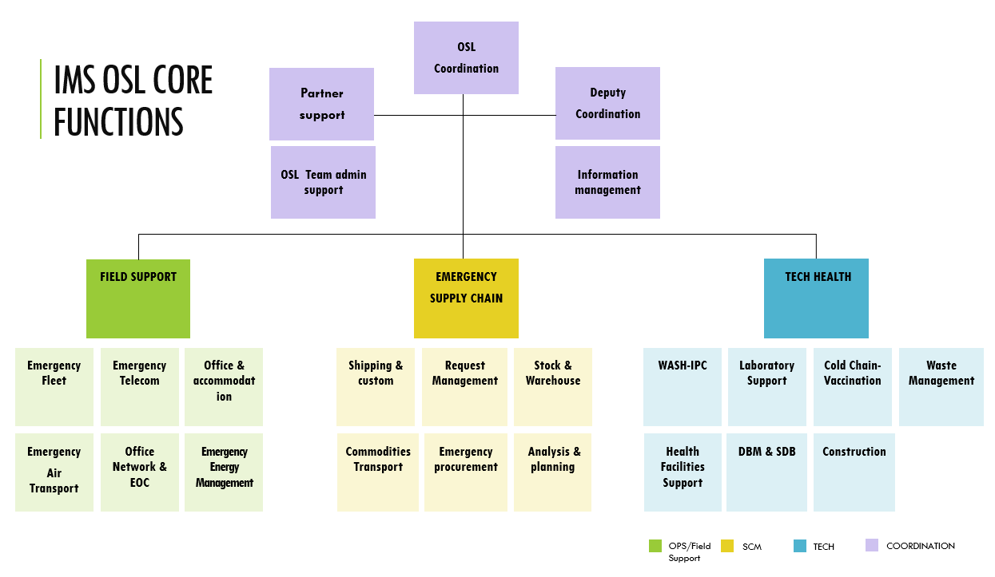
Fig: Organigram of Incident Management featuring Operations Support and Logistics functions.

The post descriptions linked to the above OSL functions include technical skills, competencies and educational and experiential requirements.

A.4 PRAGMATIC APPROACH TO LEARNING AND DEVELOPMENT

A.4.1 What OSL Will Do Through Outcomes, Outputs and Enabling Actions?
A.4 PRAGMATIC APPROACH

This part of the strategy takes the above analysis to present two outcomes, each with specific outputs, plus two enabling actions that OSL stakeholders will work towards over the coming period. They form the basis to guide annual planning and targets, which are captured within the OSL Network Training implementation plan (re. ANNEX F).

Outcome 1: OSL Staff and Roster Members have Access to Quality Learning throughout their Careers

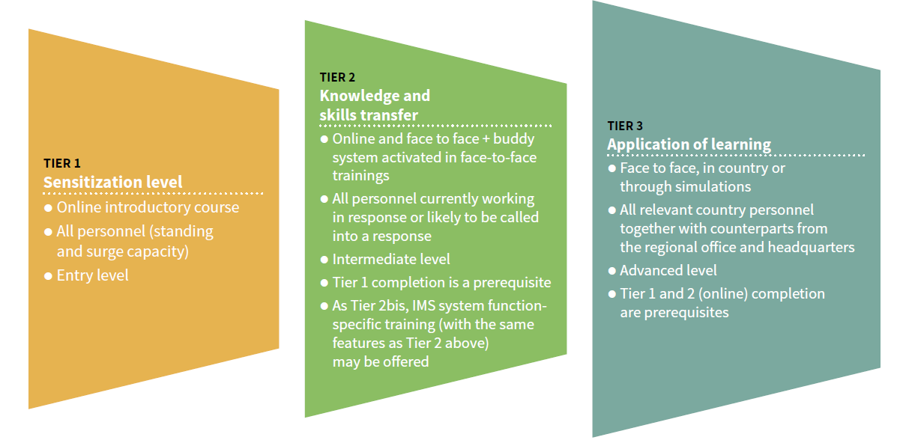
Induction is central to how newly recruited OSL personnel understand the new approach to emergencies and the culture of the Organization. The Learning and development Unit has developed a training programme - known as the WHE Incident Management System training Tier 1, Tier 2 and Tier 3 - designed to equip staff with the skills and knowledge necessary to communicate and interact with each other within the dedicated organization applied by the Organization in Health Emergencies. Advocating for the inclusion of OSL personnel within these tiers, while influencing methodology and content of each specifically at the tier 1 and 3 levels, is a pragmatic, positive outcome.

A similar three-tiered approach to OSL learning is being developed to articulate the OSL Learning framework and its foundational, technical, functional and leadership components.

At the other end, following deployment on mission, more opportunities to continue learning are to be offered. Experienced personnel need reassurance that their skills are up-to-date, have the opportunity to continue learning to ensure they remain “on top” of their game and evolve their careers.

Output 1: Promote Good Practice in Selecting Participants for Learning Initiatives

Selecting participants for learning initiatives, for example trainings or on the job mentoring, requires managerial oversight so that it is part of a systemic approach. It is imperative that initiatives complement each other, so there is a progression for all target audiences in a designated learning pathway.

OSL Incident Management Team positions include the functions described in the figure above. However not all positions or roles may be required for a given “Event” and IMT organization. The following roles are somewhat standard.

OSL Learning Approach & Pathway. A comprehensive system of OSL learning resources cultivates a prepared, willing, competent and diversified workforce of excellence for OSL work in emergencies. Appropriate learning enables a motivated OSL personnel, with internal and external partners and agencies who work closely with OSL throughout health emergency responses.

The (upcoming web based) WHO OSL network knowledge sharing centre and OpenWHO web sites are used in the first-instance to help prepare would-be candidates to comprehend the OSL culture and spirit and in meeting the necessary selection criteria. OSL then works with human resources on the deployment briefing process for all staff, including foundation learning modules on entry or prior to deployment, technical performance appraisal of deployed staff, and debriefing following deployment.

The learning pathways diagram for OSL positions is presented at Annex D, outlining learning and development opportunities for all personnel including roster applicants and members. The annual implementation plan (Annex E) leads on from this and proposes how OSL will work within the wider WHE structure to operationalize it during the first year (2019). The learning pathways diagram, therefore, communicates the transition that moves OSL from strategy to planning.

Flowing from the new pathways approach is a total refit of the portfolio for OSL learning activities, including formal training. This is illustrated by comparing the mapping of the current OSL curricula in Annex C with the proposed pathways of Annex D.

Firstly, OSL will actively engage WHE to further develop specific Logistics and operation support centered IMS modules tier 1 and 3, as well as to take part to cross cutting IMS operation support leadership workshops in Regions to reflect OSL priorities and progressive adult learning approaches. This is cost effective for OSL as it is leveraging wider WHE resources, but equally importantly fosters a mutual exchange that will benefit all. These learning opportunities enable OSL personnel to move both vertically and horizontally through the learning pathways, by being confronted to other emergency operation support contexts.

At country and regional levels, identifying the right participants from partner organizations and authorities is crucial given the increasing demands to use resources available in a cost-effective manner. Good practice in this regard would be to solicit from regional and country offices a list of ‘desired’ stakeholders to be considered for the enrollment on each course, against agreed criteria. The learning pathways model and the calendar of training events, together with other learning modalities such as on the job, intersect at this point.

Output 2: Promote Progressive and Varied Learning Methodologies Across OSL Formal Training
OSL management will continue its review of the courses to ensure there is a consistent learning methodology. Together with other units in the health emergencies programme, OSL has standards for specifying what is appropriate and realistic to achieve, so that by the end of each training event participants leave with the required knowledge, values and capacity to perform the roles required of them. Learning styles vary from person to person, so good practice is to design the course using a variety of methods to transfer the knowledge and build the confidence of all participants.

Training workshops can be a powerful learning and capacity building tool, giving participants the opportunity to dedicate time to that subject in the company of facilitators, subject matter experts (SME), their peers and relevant materials. To date, this is the primary modality for OSL to conduct its training activities. However, WHO corporately has embarked upon an ambitious e-learning programme, and health in emergencies has embraced this wholeheartedly, designing a large range of modules for staff – though often excluding roster members - to enroll in and gain certification.

There are many potential shapes and formats for e-learning, depending upon the target audience. Analysis of WHE needs suggests that having interactive online modules would plug a gap in the learning portfolio and pathways. For OSL, there is an opportunity to optimize this modality in developing the technical competencies of its personnel, and its national partners. Embedded into existing training and learning initiatives, as part of a blended learning approach, e-learning will be a core component.

Given the nature of responding to emergencies in concert with other pillars, not in silos, the scope and desire for more simulations and tabletop exercises is considerable.

The job description for OSL Officers and focal points reveals that an important element of their work is running training courses for counterparts; this does, however, vary from one region to another. While the technical expertise of OSL personnel is expected to have been ascertained before they become focal points, the support they receive in how to transfer this knowledge appropriately to their trainees is equally important, though often unverified. The capacity of those delivering training needs be raised to a point whereby they meet the agreed standards for customizing standard materials to adapt them in a meaningful and relevant way to the context. This will require coaching sessions to be incorporated into the implementation plan.

Output 3: Promote Good Practice in Selecting the Relevant Topics and Content for Training

The technical competencies that are required within OSL are mapped so that the right profile can be deployed wherever it is required globally, with support offered prior to and during missions. Given the recognized importance of working with national partners, it is vital to ensure that technical excellence remains at peak standard.

This is where the competencies and behavioural indicators breathe new life into how OSL needs to work, and its approach towards learning transfer. As much of the learning takes place at country and regional levels, tailored to the context and conducted by WHO offices, OSL will be preparing and supporting staff for this role. Learners have to be able to relate new skills and knowledge to the context specific to where they work but also in relation to the Organization’s priorities, and then build relations with their partners.

Learning Priorities are shaped by the Health Emergencies context in which OSL Personnel are working. To address learning needs and perceived priorities, the OSL Network will conduct annual Consultations with its members. An annual training need and plan will be produced to map out learning priorities, targets, budgets and to streamline resources required by Regions and Countries. This annual training plan will be imbedded in the respective workplans of OSL units around the world and globally to harmonize development, materials, delivery and prevent duplications (re. First OSL Network Training plan for 2020 in Annex. F designed during the 2019 OSL network consultation in Dubai, UAE).

OSL training has typically relied upon traditional approaches to learning; i.e. face-to-face training events designed to transfer technical information. Whilst this is understandable, by creatively shaping the learning outcomes for each event to also include attitudinal and behavioural elements, OSL will develop how its personnel work, not only what they can recite. This shifts the focus of learning towards application in a multi-faceted space, working not in isolation but alongside other pillars of the IMS or partners from national authorities and other response organizations.

Output 4: Promote Good Practice in Evaluating Learning across OSL Learning

Evaluating learning events not only helps to point out how they can be improved in future but are an entry point to an ongoing relationship with trainees as they perform the roles following the training.

There are both conceptual and practical difficulties involved in establishing a direct causal link between a training experience and changed workplace performance or benefit to the organization as a whole. As a result, drawing conclusions about the effectiveness of learning interventions is too often avoided, leaving OSL with no reliable evidence to justify investment in time or other resources. Through the enabling actions 2 and 3 of this learning strategy, OSL management commits to sustained support of simple systems which will help to identify training effectiveness over a period of time.

Gathering data about post-training behavioural changes, including examples of good performance by individuals or teams, can lead to conclusions about the possible role of the training intervention. This may not give a precise measure of the training’s effectiveness by itself, but certainly helps retain the overall focus on the reason why training is conducted and offers a way to pursue ongoing and forward-facing evaluation.

Outcome 2: The OSL Learning and Development Approach is Opportunistic yet Systemic so the Understanding of its Partners is increased.

This is important at all levels, including incident managers (IM), heads of other pillars of IMS team and national partners who set the priorities and planning. If their appreciation of what OSL personnel do is lacking, then the importance they attach to utilizing their human capacities and to learn from them will be lower. Also, they will lack the motivation to support an enabling environment in a manner that OSL team leaders and management deem appropriate. This is especially an issue since OSL is coordinating health logistics with national and international partners.

Output 1: Build and Support Knowledge Sharing for OSL’s Roster-Based Community

OSL commits to cultivating its staff and the people on its rosters ready to fulfil the OSL roles and responsibilities during emergency deployments. The community will be mainly staff at the levels of the Organization and consultants on contracts with OSL, WHE staff working with OSL and, in due time, standby partner organizations. The purpose is to enable required learning to be available and encouraged; forming and maintaining a roster that is engaged between the individual’s missions, updated in latest strategy and processes of WHO; in short, surge staff who are fit-for purpose to deploy and hit the ground running in the manner WHO would expect and require.

The members of this community will promote the experiential and exchange of learning that WHE advocates for and is outlined in its learning strategy. They will serve as resource people to support the endeavors of others, both by assisting in developing and contributing to formal training, and also in gathering and sharing experiences and knowledge, competencies and behaviours that contribute to success during emergencies.

The mapping the technical skills and behavioural competencies that members have - an ongoing work of the development of roster members and staff - will help in the planning of operations and evaluating against criteria. The community could be used as an asset that works to develop guidance documents at country level, for example.

The role of OSL management would centre on being a convener, community moderator and developer of resources that reflects the collective learning approach and weaves learning into other modalities. This is not a role that is taken lightly, and resources – both financial and human - will be identified and allocated to ensure management can perform these functions. OSL will continue working within the health in emergencies program to assist in “leading by example” in this new phase of the WHO learning process.

Output 2: Develop Learning Modules to be used in Courses for Health Emergencies Staff, including Surge Capacity Teams and Partner Agencies

Non-OSL WHO Emergency Personnel often have little more than a cursory understanding of operations support and logistics; moreover, some ingrained preconceptions are typically in existence. There is not just a lack of basic knowledge but an apprehension to engage, fearing OSL is a territory reserved only for expert logisticians. In the present operational climate, in many Country or Regional Offices dedicated Operations and Logistics focal points are rare. This means that the burden for operations and logistics is often placed on administrative officers or other non-specialized personnel stepping in and assuming the role. To work effectively, they need colleagues to be able to relate to OSL competencies and facilitate their integration and collaboration as relevant. On many counts there is a need to demystify what OSL is amongst general WHO staff, especially in relation to health emergencies work.

As described above, the tabletop and simulation exercises for working together are extremely appropriate and provide a motivation and importance for e-learning to be completed conscientiously. Such an approach allows any subsequent collaborating on operations to be more effective.

Output 3: Build a Pool of Learning Resources and Modules on Technical Logistics in Practice

Much of the technical knowledge in the training courses that OSL currently has at its disposal is delivered through classroom and hands-on based training. The presentation, session plans and relevant learning material used will be collected and, after quality control is carried out, stored at a central location on the OSL section of the WHO Sharepoint workspace. This will be the go-to-place for OSL learning materials, accessible to the wider WHE community. As well as remaining in presentation format, they can/will be translated into video format and e-learning as needed, based on OSL strategy and learning plan

Case studies offer a valuable means to look at the application of the principles of OSL. There is of course, a danger of over-standardizing learning modules, so they must be tailored by appropriately skilled personnel, and shaped to context at country level through ongoing dialogue and the training design skills that needs to be established within Regional and Country offices, in line with Learning standards and adult learning principles described in annex. A learning developing toolkit will guide the development of future trainings.

In addition to the above, OSL personnel are responsible for collecting operational lessons throughout a response. To the greatest extent possible, experiential learning should lead to operational adjustments in real-time. For learning actions that cannot be taken in real-time, they are collected and included in the OSL After Action Review, End of Mission Reports and debrief sessions that are shared with the OSL team. The OSL Support Lead has overall responsibility for ensuring both that past learning from previous operations is applied in real-time and that current operational learning is collected for future OSL action.

A.4.2 How OSL Will Do It?

It is vital to influence the environment in which the learning initiatives described in this strategy will take place. Three enabling actions are identified which will lead to the creation of a positive climate.

Enabling Action 1: Encourage a Culture of Nurturing and Exchange

Nurturing means identifying who are the human assets that the organization has and investing in them, while expecting those people to make a commitment to WHO. In OSL terms, as discussed above, managing the rosters more systemically and offering an engagement with the people will be key. Rosters are not only a reactive mechanism utilized in acute need, but a forward-looking resource that grows with the learning culture of the organization. At a corporate level, WHO sees strengthening and formalizing the WHE rosters as one way to build a fit-for-purpose workforce. While this is coming to pass, OSL will work with HR to align and preempt these more managed practices.

Intrinsically tied to this are the learning pathways for each of the positions in OSL, making it clear how personnel can switch roles and progress careers within OSL and towards other functions within the IMST structure, including Incident manager.

For learning to impact beyond the classroom, the support and active participation of line managers is of paramount importance. Trainees need to have the opportunity and responsibility to put what they gained into practice. Evaluating how the training is making real changes will require innovative, realistic approaches to overcome the “difficulty” as explained in outcome 2 of this strategy. The proposed tools include knowledge sharing, positive debriefing, the buddy system and on-the-job mentoring, making it everybody’s business to share knowledge and contribute to the development and the learning of OSL Personnel.

These tools will be integrated into social-networking tools to keep developing OSL community of practice and network and widen the sharing of OSL knowledge, Learning and practices to wider circles of recipients whenever possible and appropriate (re. 2019 OSL Network Consultation in Dubai Report).

Enabling Action 2: Demonstrate Strategic Alignment with the Learning and Development Culture of WHE Work

OSL management will reach out to colleagues and WHE leadership to ensure all personnel are committed to participating in IMS Tier 1, 2 and 3 training programmes. Learning from these trainings will be brought to life and made relevant through regular OSL team meetings, simulations and tabletop exercises.
Further OSL management will support the development of induction OSL mandatory trainings and learning materials to develop the OSL learning culture and values.

More technical trainings will take place based on priorities of the Organizations identified during annual OSL Network Meetings by OSL country and Regions colleagues.

While HR systems are gathering pace to keep up with the rate of transformation, this breathing life into the new ways of working – as captured in the behavioural competencies - will be pioneered by OSL management.

The new OSL learning and development strategy is the first initiative to consult personnel and partners on their understanding of the competencies and behavioural indicators in the OSL context .

A second step is in ensuring that these competencies are brought into the learning initiatives, including the more experiential methodologies that WHE advocates for. OSL management endorses the Buddy Support System (BSS) and will initiate a pilot during 2020; the corporate performance management system will be a conduit to share good practice related to quality learning.

Enabling Action 3: Cooperate with Learning Specialists to Promote High Quality Learning

Within the health in emergencies scope and the wider WHO, a collection of experts performs dedicated roles in training coordination, notably at the WHO Academy.

As this matures, OSL will continue engaging the learning expertise of pre-identified and contracted professionals to work on the delivery of courses, to identify learning needs and to evaluate the effectiveness of training solutions. More than fifty long-term agreements are in place with approved training providers. OSL management will continue to harness this expertise to add essential value based on country-level priorities.

Further a pool of Trainers specialized in OSL will be established through annual Peer to Peer training workshops to
promote Adult Learning Principles and knowledge and adherence to best practices applying the OSL Training Development tool kit to support the quality and standards of training developed.

ANNEX B - COMPETENCY FRAMEWORK FOR OSL (5 core WHE and WHO Competencies)

WHO/WHE Competency | How does OSL understand this competency?  (Definition) | How does OSL recognise when staff are demonstrating it?  (Indicators)
Teamwork  Personnel develop and promote effective relationships with colleagues and team members. Deal constructively with conflicts. | OSL personnel usually work with colleagues from a wide array of backgrounds, cultures, experiences, skill sets and roles.  Team members will often change on a frequent basis, fulfilling various functions, often alongside people deployed from rosters.  OSL personnel need to integrate rapidly, build swift trust with fellow team members and quickly establish means to contribute positive, productive and effective ways of working together in a multicultural environment. | Behavioural indicators:  OSL personnel will list/describe (Knowledge):  - The agreed ways of working, roles and responsibilities of OSL and IMT team members.  - Individual roles within the team and collective team roles, demonstrating a practical and flexible understanding.  - Potential sources of conflict within a team, and ways to facilitate its resolution in the context.  OSL personnel will be able to (Skills):  - Work collaboratively with team members for solution-oriented decision-making.  - Support fellow team members, build rapport and empower colleagues and partners.  - Contribute to the security, safety, well-being and Duty-of-Care amongst the team.  - Build internal and external partner capacity through logistics and supply chain operations.  OSL will value (Attitudes and attributes):  - Team members’ ideas and expertise to integrate their input into her/his own work.  - Learning from others with different ways of doing things.  - The common goals, purpose, values and mission of the team.  - Establishing ”swift trust” with team members and partners.  - Working cross-functionally and empathising constructively beyond their functional role.  - Respect cultural differences.  - A fun and rewarding environment full of good humour while always being respectful of one another.

Communication  Personnel express oneself clearly in conversation and interaction with others; actively listen. Produce effective written communications. Ensure that information is shared. | OSL personnel are able to provide clear, credible and trusted communications when working with team members they may not have worked with previously, and with national and international partners in the context they operate in. | Behavioural indicators:  OSL personnel will list/describe (Knowledge):  - The main norms and behaviours of the culture they are working in with active support of OSL systems, where this knowledge can be obtained is a key enabler.  - The information that is appropriate for them to share or to request with specific partners.  - The power of social media and use it effectively per WHO rules of engagement related to social media.  - Email etiquette and principles for constructive exchange and communication.  OSL personnel will be able to (Skills):  - Adjust communication mediums (written and spoken) and language for specific target audiences (e.g. teams, partners, public).  - Gather data to inform evidence-based decision-making.  - Convey information and opinions in a structured, respectfull, constructive and credible way.  - Use language that is respectfull, understandable, timely and jargon-free.  - Listen to others.  OSL personnel will value (Attitudes and attributes):  - Actively listening and encouraging team members, representatives of Member States and partner stakeholders to share their perspectives and experiences.  - Opposing respectfully opinions amongst a diverse array of stakeholders when necessary and seek them out to reach acceptable compromises.  - Keeping different stakeholders informed of key and relevant issues.

Moving forward in a changing environment  Personnel are open to and propose new approaches and ideas. Adapt and respond positively to change. | OSL emergency personnel work in rapidly changing, highly stressful and often insecure emergency contexts.  Natural and man-made hazards (including high-threat pathogens) pose threats to their own health and safety as well as the operation and require flexible, innovative, empathetic and responsible behaviors, identifying and managing risk effectively to achieve the best positive compromised outcome. | Behavioural indicators:  OSL personnel will list/describe (Knowledge):  - Real-time lessons learned that can be applied in the context they are operating.  - How people are being affected, so the focus is on them and towards positive health outcomes for them.  - Security guidelines, rules, standard operating procedures and policies related to security, safety, staff wellbeing and Duty of Care.  - WHE change management initiatives.  - Documented “no regrets” decisions.  OSL personnel will be able to (Skills):  - Maintain personal well-being, safety and duty of care of one’s self and others during working hours and non-working hours.  - Recognize their own stress levels and take proactive steps to reduce stress, remaining constructive and positive.  - Adapt readily, rapidly and efficiently to changing priorities and demands so supporting decisions made based on the information available at that time, even incomplete.  - Rapidly integrate with new team members, stakeholders and partners in a multicultural environment.  - Demonstrate and model flexibility and adaptability when rapid change, extreme complexity and uncertain environments are the norm.  OSL personnel will value (Attitudes and attributes):  - Develop risk management capabilities (including risk identification, critical thinking ability and emergency context risk assessments).  - New ideas, solution-oriented and proactive with innovative working methods that are relevant and useful.

Applying technical expertise  Personnel apply specialist and detailed technical expertise; develops job knowledge and expertise (theoretical and practical) through continual professional development; demonstrates an understanding of different WHO functional areas. | Promotes and exemplifies the highest professional and ethical behaviour and commitment to accuracy, precision and rigor in all decisions and communications, while also remaining practical in the OSL context. | Behavioural indicators:  OSL personnel will list/describe (Knowledge):  - The best, most up-to-date, cutting-edge knowledge, practices and skills and challenge current thinking when the context requires.  - Innovations, research and data to constantly improve emergency public health interventions.  OSL personnel will be able to (Skills):  - Apply technical expertise, practices and knowledge while adapting advice so it is technically, financially (best value for money), and culturally appropriate, sustainable and suitable vis-a-vis the socio-economic context of the country.  - Use data and evidence to support emergency public health interventions and decision-making that is solution-oriented, towards recipients longer term benefits when possible.  - Take decisions even when information is incomplete, as is often the case in emergencies.  OSL personnel will value (Attitudes and attributes):  - The functionality of other emergency technical expertise outside of their specific area of work or regular ways of working.  - Strengthening the capacity of partners (particularly national partners) to reduce, limit and finally withdraw reliance on WHO emergency support functions.  - Transferring knowledge, practices, behaviours, skills and appropriate tools to other emergency responders, national and international personnel, and volunteers, through the mutual provision of tools, training and expert guidance.

Building & Promoting Partnership across the Organization and beyond  Personnel develop and strengthen internal and external partnerships that can provide information, assistance and support to the Organization. Identify and use synergies across the Organization and with external partners. | Building and promoting partnerships is an essential aspect of OSL emergency work so information is exchanged, and assistance to the emergency public health intervention is timely and builds the capacity of partners | Behavioural indicators:  OSL personnel will list/describe (Knowledge):  - How best to engage partners while also promoting WHO’s leadership in health emergencies.  - Understand WHO’s role and objectives in public health emergencies and ensure that partners do too.  OSL personnel will be able to (Skills):  - Proactively coordinate, collaborate and establish synergies with emergency public health partners.  - Establish trust by showing added value to convince partners at the right levels and engage in joint decision-making where appropriate.  - Actively design and facilitate emergency capacity building to share and transfer effectively knowledge, skills, tools and practices in line with OSL standards for learning.  - Promote WHO partners.  - Build and leverage a wide range of partnerships and networks in areas of OSL’s technical competencies and broader to the benefit of WHO emergency public health interventions.  OSL personnel will value (Attitudes and attributes):  - Learning from partners and recipients and applying innovative ways of working to the benefit of WHO programming for positive public health outcomes.  - Sharing credit with partners and stakeholders for collaborative work.

ANNEX C - OSL LEARNING CURRICULA MAPPING

The curricula mapping revealed a situation of flux. New initiatives within OSL and more broadly WHE were forging ahead to embrace the aspirational corporate approach. This happened in the recent IMT leadership training in Dakar in June/July 2018, where OSL provided content-based input and also influenced the methodology of the training.

In addition, the active contribution the unit makes to Tier 1, 2 and 3 training development and requesting regional and country staff to attend shows OSL management’s commitment to new thinking. The OSL L&D strategy articulates an ongoing management commission, with the aspiration being all new staff pass through the tiers when most appropriate.

In concert, parts of the unit are following a more business as usual approach, organizing country or global classroom-based trainings that focus on required technical skills, and sharing experience. TECH notably has rolled out its standard courses for ICT, SDB/DBM and Cholera in numerous locations in 3 languages and continues to plan for the coming years.

Fleet too, sees value in its face-to-face training programme key countries and Regions. Other parts such as Supply Chain Management are showing evidence they are innovating to meet new approaches by the end of 2019.

This, at its heart, is what the learning strategy seeks to address with a core accepted approach to learning and following recognised quality standards in how to identify, design, deliver and evaluate learning for OSL. To support efficient and harmonized development, the OSL training development toolkit has been created from the interaction between OSL personnel being trained and Learning experts engaged to support training developments.

Yet others had a wait and see approach, justified given the changes across WHE. Many ideas were revealed- notably in the online learning sphere, or mentoring- that staff were waiting for opportune moments to share or push for management support.

The most prominent gap revealed in the mapping of the OSL LDS was in reaching out to roster members and equipping them with an appreciation of how to deploy their technical skills as a WHO officer on mission.

The learning pathways, and the OSL learning framework in Annex D, introduce a mechanism so that roster members feel part of the system, and deploy hitting the ground running prepared with knowledge coming from their peers and drawn the wider OSL/WHE community.
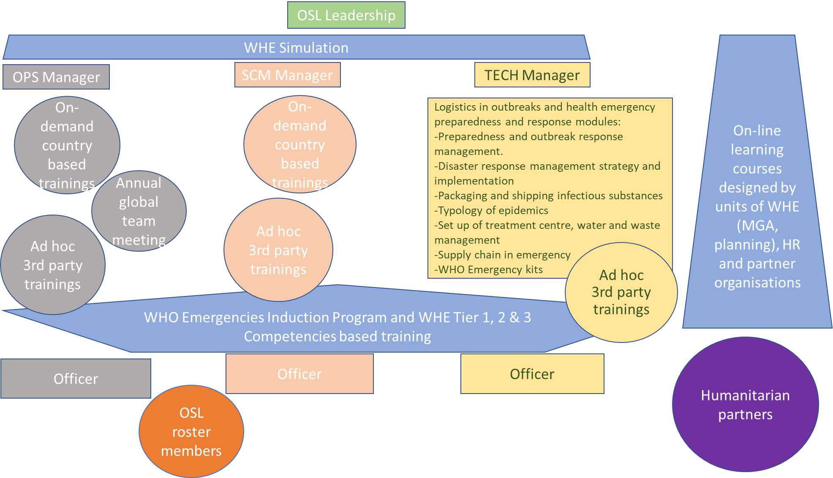
.
ANNEX D - OSL LEARNING PATHWAYS

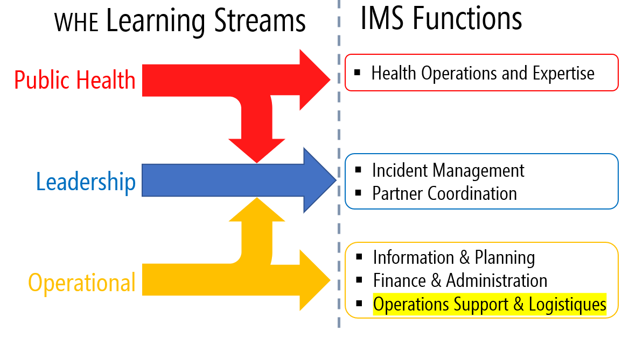
The OSL learning stream is part of the WHE Operation stream .
OSL Learning Pathways strive to be inclusive for all personnel OSL relies on to deliver its emergency mandate. Personnel can meet their learning and development needs as they enter, and progress their careers within OSL, and more widely, WHO emergency work.

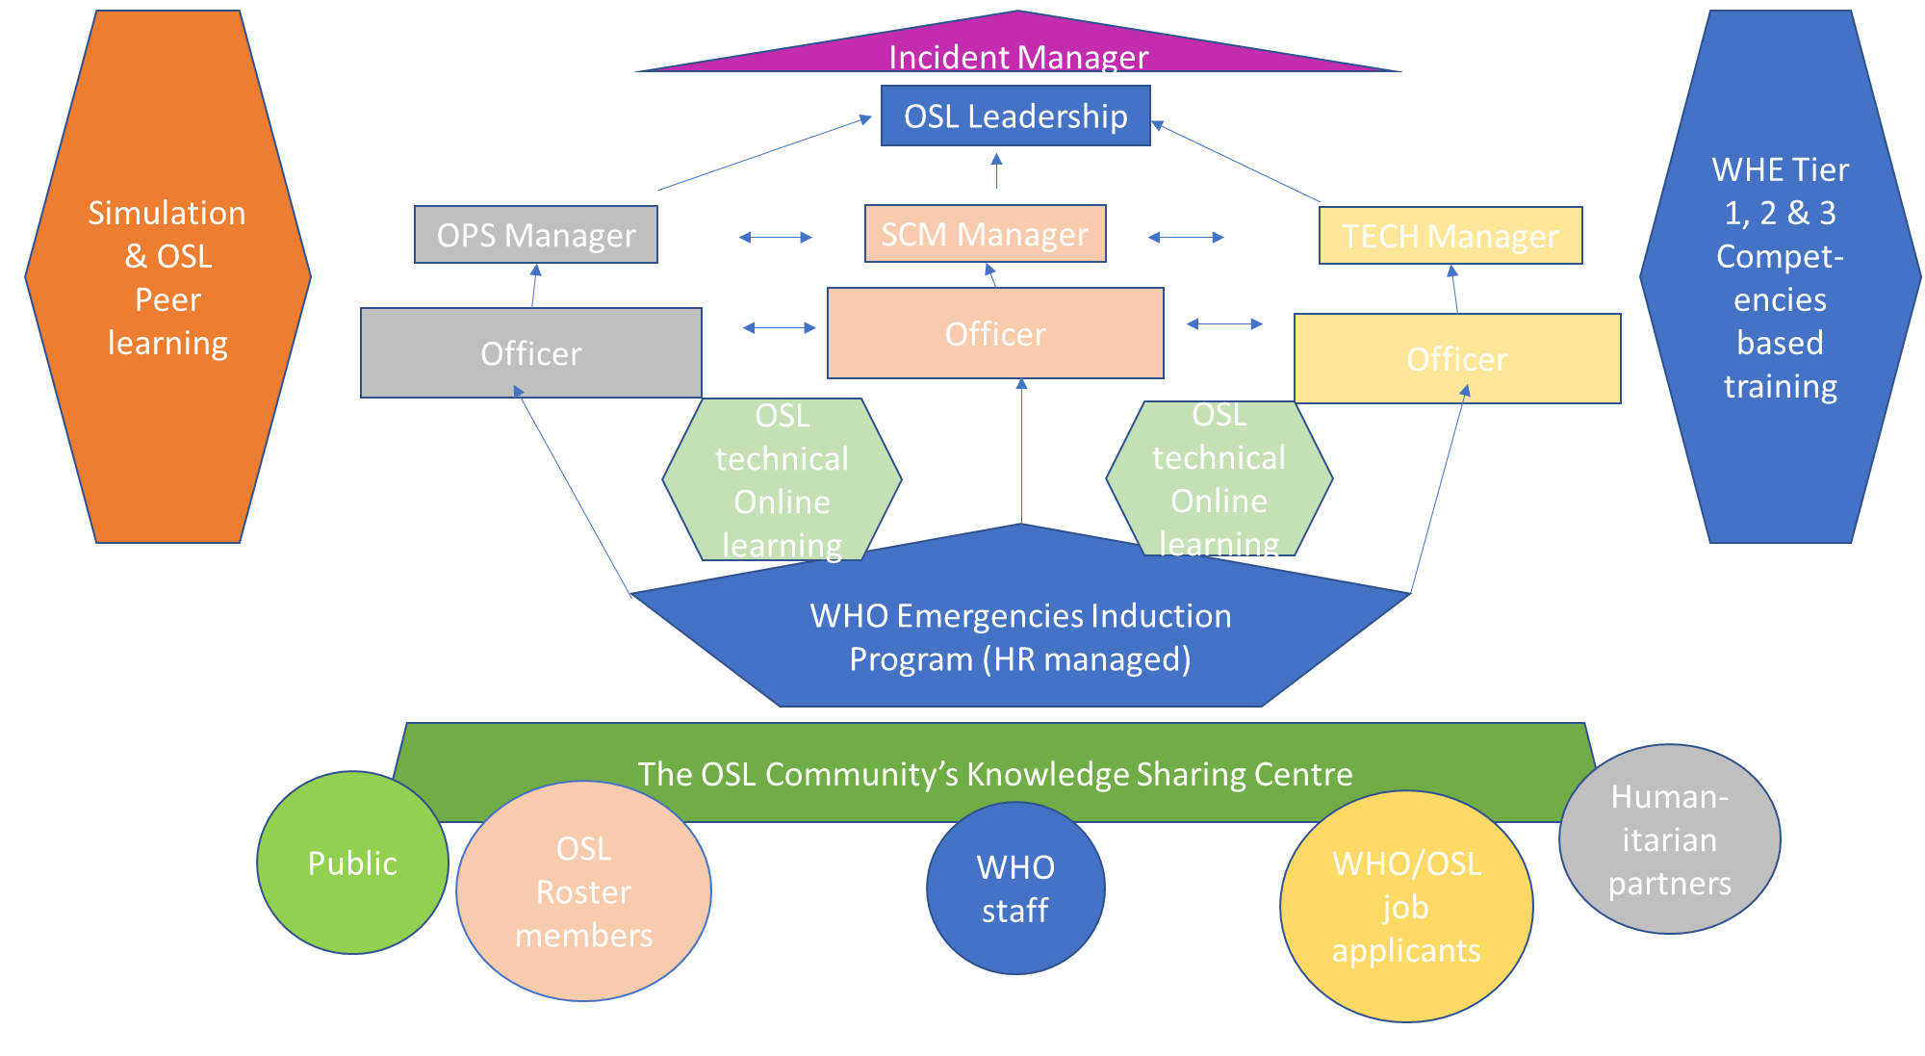
A more detailed expression of the Learning pathways is the (UPCOMING) OSL competency matrix that shows requirements for OSL key functions and de facto learning requirement to move from one function to another.

An outcome of recent OSL network meetings, the (UPCOMING) OSL Community Knowledge Sharing Centre (build around the OSL sharepoint site, the corporate Ilearn site and the Emergency focus open to public MOOC at openWHO.org) will be accessible to all those with a need for the knowledge, skills and experience that is expected of OSL personnel.

Primarily, a self-accessing resource where motivated individuals can interact with up-to-date strategic documents on the WHO approach in emergencies, learning and reflection from recent missions OSL staff were deployed on, and case studies that reflect the skills and behavioral competencies expected of OSL personnel. Moreover, many of the OSL technical e-learning courses will be accessible through this community, meaning not only OSL staff, but also partners and roster members can advance their learning.

The learning pathways are designed so that there is vertical progression for personnel within OSL technical areas and their management. Learning pathways are also connecting OSL technical areas to allow OSL personnel to further develop competencies in all OSL expertise as required by operational priorities, opportunities and personnel preferences.

All OSL learning pathways allow OSL Personnel development towards WHE Leadership Learning stream and towards IMS leadership roles. By following IMS tiered trainings and availing themselves to the experiential learning of peers and senior colleagues during emergencies and IMS Leadership workshops, vertical progression of OSL Personnel can be mapped and planned for.

Regular simulations testing performance and introducing personnel to good practice and tools, is a key feature of how OSL within WHE will cultivate its personnel to flourish in more leading roles.

For that reason IMS Emergencies Leadership Workshops of the WHE Leadership Stream requires regularly significant input from OSL management to ensure it is relevant to its personnel and well-integrated with other key operation support functions and roles working alongside their colleagues and partners, such as in priority Information and Planning, Finance and Administration as well as other Health related Expertise for Information Prevention and Control (IPC), Diagnostics, Immunization, Clinical Management, Community Engagement and on a case by case basis preparedness and readiness.

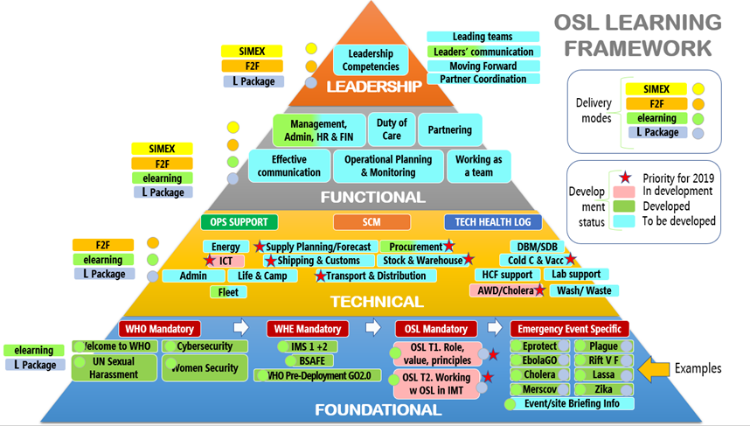
Learning and Evaluation is geared towards practical behavioral competencies demonstration by OSL Personnel to ensure that IMS teams communicate and display exemplary teamwork in often fast changing, dynamic environments.

To integrate the leadership Learning stream, OSL personnel must accrue induction and other OSL foundational learning, followed by full OSL technical and functional learning as illustrated by the OSL Learning Framework chart.
Their progression is tracked through positive-looking performance management systems
EMERGENCY OPS SUPPORT  - OSL Team Leader  OPS Team Manager  - Fleet Manager, Officer and Assistant  - Office & Admin OSL Officer & Assistant  - Office & Accomodation Officer  - Energy Officer  - Telecom Officer  - Information Management OSL Officer  - Driver  - Air Transport Officer  - Energy Management Officer | EMERGENCY SCM  - SCM Team Manager  - SCM Officer & Assistant  - Supply Planning & Request Officer  - Procurement & Local purchase Officer & Assistant  - Stock & Warehouse  Officer & Assistants  - In-bound Shipping & Customs Officer  - Transport & Distribution Officer | TECH HEALTH LOG  - TECH Team Manager  - TECH OSL Officer & Assistant  - WASH-IPC OSL Officer  - Laboratory Support OSL Officer  - Cold Chain-Vaccination OSL Officer  - Health Facilities Support OSL Officer  - DBM/SDB OSL Officer  - Waste Management OSL Officer  - Construction OSL Officer

Further they must demonstrate positive experience in emergencies, attesting that the required competencies have been not only acquired but also demonstrated in operations for any of the positions in the table below.

The IMS Tier 1, 2, and 3 complete the mandatory requirements towards career development for the Leadership Stream.

The officer level positions shown in the table above will be expected upon entry to OSL to have the technical skills for that role.

To move into other roles within that unit, or to move horizontally to other units within OSL, a range of e-learning trainings will be developed, equipping personnel with the knowledge in an efficient manner.

These will be complemented by regular face-to-face gatherings where this knowledge can be put to practice, and the more behavioural competencies also developed so that the what (skills) and how (behavioural) are in sync.

ANNEX E - IMPLEMENTATION PLAN 2019-2020

This implementation plan for the learning and development strategy (LDS) adopted by the OSL management is guided by two main, realistic, aims for the period 2020-2021:

- To Secure a solid foundation for the LDS, with delivery of the outputs owned by OSL, and interpreted in a manner to be built upon progressively.

This sets the tone and clarifies for OSL personnel and its partners how OSL will work now and into the future. To this end, the monitoring and ongoing reflection on progress of the LDS and implementation plan activities is of significant importance. Walking purposively and giving partners confidence that you will not topple over but arrive at the desired destination, underlines the thinking of this plan, written in outline, with the finer detail to be determined by the OSL champions team in HQ and Regions (see enabling action 1) and the learning specialists that will work alongside (see enabling action 3).

- To establish the mutually symbiotic relationship with the other constituents of the IMS in learning and development. Notably, by integrating with Human Resources Management (HR), Planning, as well as Finance and Administration units part of the Operational Learning Stream, OSL can prioritize how to deploy the two modalities the LDS has identified for stealthily striding forwards in concert: OSL innovating new approaches and tools for learning where required; and alternatively working from behind, through and with, other components to support initiatives they are leading on. Key in determining the desired modality at specific times is that there is an efficiency and appropriacy in allocating resources, and a built-in flexibility that allows fluidity between the two modalities.

The implementation plan for the coming 12-18 months starts with the enabling actions of the LDS towards the overall goal of:

OSL personnel are proactive, competent and valued members of WHO’s IMS.

There are several variations for how the plan can be constructed from this basis.

The Plan C option
This is where OSL commits in this time period to deliver one part of the strategy with the resources it devotes; focusing mainly on establishing the enabling actions, so that there is a solid foundation from which OSL can build in future work plans. The merits of this are that it allows OSL management to focus more on the systems and relationships that will be required to make the strategy meaningful and be successful in ushering in a new culture.

Attention should paid to the wording or the enabling actions; they are intricate yet profound and require more than a cursory exposure, but rather an effective and participatory engagement so they are internalized within the global team.

The Plan B option
Realistically however, only delivering the enabling actions is not sufficient; practical trainings and new approaches will need to be developed to build capacity of personnel, and at the same time be seen to be progressing to maintain the enthusiasm and commitment of stakeholders. Therefore, the enabling actions and specific outputs of Outcomes 1 & 2 (highlighted and explained below), will be required. In the view of the consultants tasked with phase 1 of the LDS preparatory work, this is the optimal plan option as it is aspirational, can operationalize some of the work on incorporating the OSL interpretation of the competency framework into learning initiatives and realistically trial the evaluation approach. Moreover, without being overly ambitious, the OSL team can identify and design the trainings most relevant, such as cholera, ICT and OSL Foundations and values.

The Plan A option
The final option, Plan A is a full scope of work that aspires to build the entire package rapidly. The drawbacks of this, aside for costs in time of personnel/ management and budgetary, are that it falls into the trap of putting primacy on action rather than a strategic approach, and hence taking forward initiatives that are not fully thought through or replicate those that others are working with.

A training project workplan and budget for 2020/2021 is being developed in coordination with Regional Offices to estimate resources and refine timelines (re. Draft OSL training plan by region). This plan is presented below as aspirational and will be revised based on the Organization’s emergencies priorities with Regional stakeholders and other members of the OSL Network. Plans are established during OSL network meetings at the beginning and/or the end of of each year.

The plan presented below was devised during the Jan 2020 OSL Network Meeting in Dubai.

Whichever plan options Regions’ OSL management favors, careful and methodical communication with colleagues in other regions and countries needs to be maintained via the OSL network so that all are on aware of opportunities and challenges that govern learning and development of OSL personnel.

This, by design, is at the core of the enabling actions that should be articulated in OSL 2020-2022 workplan.
Enabling Action 1: Encourage a Culture of Nurturing and Exchange
Activity:

- Appoint a team of OSL LDS champions from the HQ and global team, with one designated focal point lead, ideally HQ-based and with a reporting line to OSL chief. The positions (4) will be for a 12-month period and be guided by a ToR on responsibilities, timeframes, budget and reporting lines.
  - Budget: Internal OSL personnel resources, so time devoted (40 hours per personnel).

- Map the support and active participation of line managers that will be required to deliver the strategy. For management, promoting the new culture of learning, the standards and principles of how OSL does learning and development within WHE is important and needs defining so that resources (time primarily) are allocated.
  - Budget: Internal resources of OSL personnel, so time devoted written into ToRs.

- Schedule a series of briefings on the LDS and the culture it heralds. This will be designed and delivered by the champions team to reach all parts of OSL and key partners within and without WHE, through face-to-face and remote sessions.
  - This should be built into the existing calendar of events to contain a module on LDS.

- Clarify each of the positions in the OSL organigram, with the technical and behavioural competencies.
  - Ongoing management responsibility, so no extra cost.

- OSL management endorses the Buddy Support System (BSS), as part of the wider WHE approach, and will initiate a pilot during 2019. Utilizing, and working with HR to develop further, the BSS exemplifies the enabling action of nurturing. The corporate performance management system will be a conduit to share good practice related to quality learning.
Budget: BSS trial will require coaching and mentoring from experienced experts, possibly not in-house.

- Other proposed activities that will deliver this crucial enabling action are: positive-focused debriefings, including post-mission, as part of the appraisal system so that useful case studies of competencies-in-action can be drafted. On-the-job mentoring, so that personnel pursuing learning initiatives have the opportunity and responsibility to develop by putting what they gained into practice.
Budget: Nothing specific, as these activities fall under the category on ongoing business, done better in line with the WHE approach. This enabling action activity dovetails with the next, to be a conscientious, proactive component of WHE moving forward.

Enabling Action 2: Demonstrate Strategic Alignment with the Learning and Development Culture of WHE Work

Activity:

- OSL management reach out to colleagues and WHE leadership to ensure all personnel are committed to participating in OSL foundation learning initiatives and to IMS Tier 1, 2 and 3 training programmes.
  - Budget: again, the beauty lies in not devoting extra resources to doing different things, rather consciously doing the required activities in a manner that adheres to, and breathes life into, the L&D culture of WHE.

- Embrace and institutionalise the new ways of working captured in the behavioural competencies. Deliberately, OSL management has taken the approach of interpreting the existing behavioural competencies that WHE adopted, in turn which were built upon from the corporate level. What they have done to add meaning and greater value is to focus in on the most relevant to OSL personnel and write them in language and with examples that speak to its parish.
  - Budget: Time during existing, ongoing OSL events and meetings, with greater effort to make them inclusive and catering to its global team.

- Ensure that these competencies are brought into the learning initiatives, including the more experiential methodologies that WHE advocates for.
  - Budget: Working with the learning specialist identified in enabling action 3, and in the development of outputs for outcomes 1 and 2, these competencies need to be woven into the fabric, and learning outcomes, of all learning initiatives be they online, face-to-face of SIMEX. Therefore, budget is the fee of the learning specialist, and costs of running pilots and prototypes.

- OSL management will work with colleagues across WHE on developing the corporate performance management system as a conduit for sharing good practice on quality learning.

- Budget: Nothing specific, as these activities fall under the category on ongoing business, done better in line with the WHE approach. This enabling action activity dovetails with the next, to be a conscientious, proactive component of WHE moving forward.
Enabling Action 3: Cooperate with Learning Specialists to Promote High Quality Learning
Activity:

- Given the competency profile within OSL, engaging an external yet tenured, generalist learning expert is a fundamental requirement for OSL to roll out the LDS. The LDS and annexii, together with the plethora of tools and manuals, is an outstanding basis for OSL to enter into the next phase with real confidence that it can deliver the culture change required for it to be a forward moving component of WHE. Already OSL management, through its focal point at HQ, has formed a cadre of learning experts to deliver a range of initiatives, delivered in a proactive, flexible and generous manner. This must continue in a formalised Terms Of Reference (ToRs) so that outcomes 1 and 2 can be appropriately planned and rolled out, and the learning specialist completely conversant in the enabling actions.

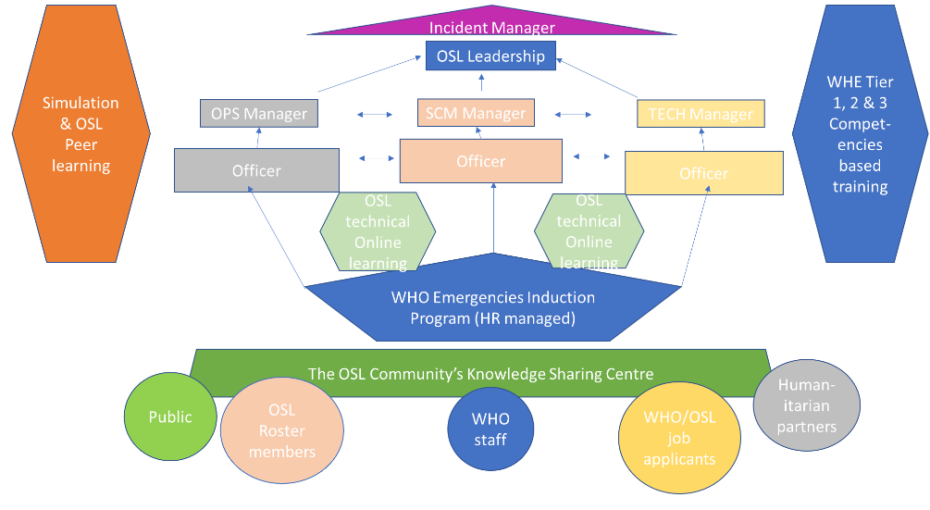
- The reflection below under the two outcomes is a starting point for this more detailed planning not long after the three enabling actions have been embarked upon. At this vantage point, it would appear to make logical sense to deliver all outputs of Outcome 1, looking at bringing greater quality and rigor into OSL’s approach to learning, first, then move to Outcome 2, which is more the what and when of learning events. However, an urgency to set up the learning community to deliver the foundational learnings that help induct new personnel, including roster members, may become unavoidable. Equally, to demonstrate clear progress and build positive momentum that the LDS is heralding in a new improved way of working, rolling out outputs of Outcome 2 may be wise. Certainly, the natural progression of enabling actions, to Outcome 1, to Outcome 2 should be a guide to the team managing the implementation. In short, this progression reflects the spirit of OSL learning- focus on how we do things (good practice, reflection), not just what we do (run training be it face-to-face or online).

  - Budget: Over a 12 month, rolling contract, a minimum of 60 working days should be allocated to a learning specialist. This person would work with others to design, deliver and evaluate, with OSL personnel the specific learning initiatives.

OUTCOME 1: OSL staff and roster members have access to quality learning throughout their careers
From the perspectives of OSL learning priorities and global distribution, profile and type of OSL personnel involved in emergencies while considering the volume/scope of learning activities that is required to deliver the expected culture change, a combination of complementary approaches and methods is called for.

For simplicity of planning, OSL have developed a diagram (below) describing the type of learning most appropriate at different levels of personnel (leadership, management, officer) and how learning pathways allow horizontal and vertical movement.

OUTPUT 1: good practice in selecting participants for learning initiatives

- Inspired by the enabling actions to take an inclusive, nurturing approach to its personnel, the learning pathways are relevant to all, including roster members. This was a vital theme emerging from the consultation to the LDS. Another recurring ask was to ensure that all OSL personnel is equipped to perform with quality through access to foundation learnings initially.
- Translated into a concrete activity, OSL will align the personnel development needs of each of its personnel, with a learning initiative in 2020-21. For new personnel this means into the foundation learnings; for officers aspiring to move vertically into more senior positions a place on the SIMEX and/or Face-to-Face learnings of the functional learnings.
- OSL will Implement a transparent application process for enrolling on courses, with a defined criterion of knowledge, experience and demonstrated commitment to utilize the learning from the training afterwards. This naturally links to output 4 on evaluation
- OSL management responsibility is to act upon this commitment by dedicating time and enabling OSL Personnel.

OUTPUT 2: Progressive and Varied Learning Methodology across OSL Formal Training

- The learning pathways diagrams show the scale of the learning and development challenge OSL is embarking upon. It will call for a prioritizing of resources and identification of the most efficient and effective method for each type of learning. To this end, the most appropriate way of building technical competence is likely to be through online modules. They can reach a wider number of people and type (consultants, partners, roster members, staff, IMT colleagues, health workers and Partners).
- Moreover, promoting a nurturing and sharing knowledge culture is a key enabling action for the success of the LDS, the mutually supporting experiential components of learning will complement e-learning.

OUTPUT 3: Good Practice in Selecting the Relevant Topics and Content for Training

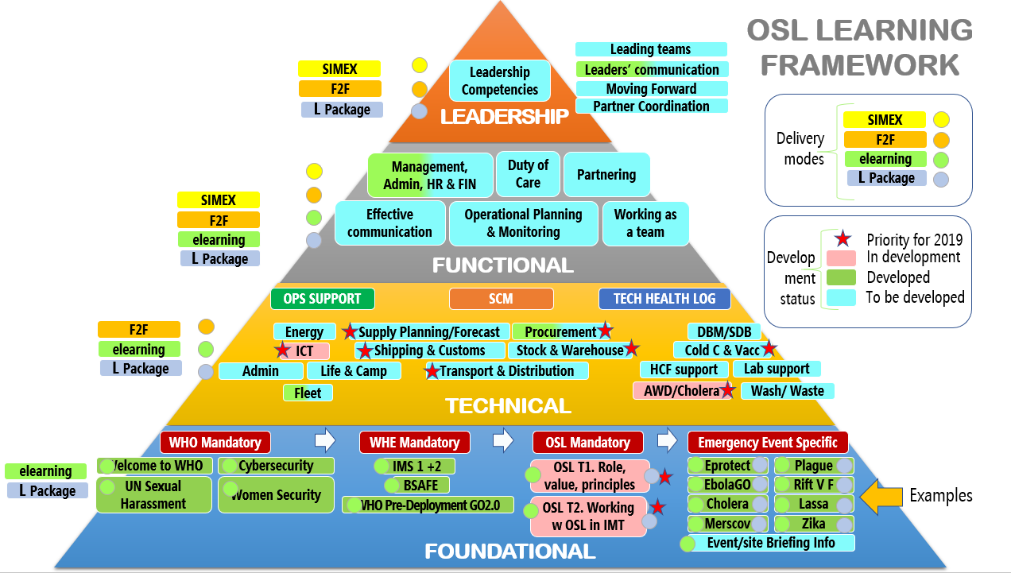
- The identified topics in the OSL Learning Framework diagram below, emerging from a participatory process within OSL and partners, are the basis for the content. In the next phase, learning specialists work with the OSL subject matter experts to design the trainings. For the technical learnings, a mapping revealed that much content exists, but it is in silos across OSL globally and is not peer reviewed. The primary action therefore is to conduct this exercise, and also identify which behavioural competencies are required for the personnel to perform this technical skill in practice in the manner OSL deem to be appropriate. The second is for the appropriate methodology of learning to be utilized, which falls under output 2, above.

OUTPUT 4: Good Practice in Evaluating Learning across OSL Learning.

- Several tools for evaluating formal face-to-face training and Simex trainings have been developed and used in the recent Dakar and Aman Leadership trainings; They are included in the OSL Training Development toolkit:
- Post training assessment form for participants
- Post training peer to peer facilitators training forms
- Pre & post training voting system to identify plus and minus
- Pre & post knowledge survey
- Peer to peer on-going and post training participant competency feedback
- Post training participants competency evaluation

- Currently, these evaluation methods focus on knowledge and immediate restitution. However, extensive work has been done and continues within WHE on standards for evaluation with continuous learning tools such as the app My Billion that keeps enabling participants engagement on learning topics.

The implementation plan henceforth is to continue this work and make the tools even more relevant for online and SIMEX/DTXs.

OUTCOME 2: OSL Learning and Development Approach is Opportunistic yet systemic, so the Understanding of its Partners is Increased

OUTPUT 1: the OSL Network Knowledge Sharing Centre to include Roster Members and Partners

- More detailed planning, by an expert in building such platforms is required. The LDS consultation identified a gap, which a network knowledge sharing centre would address by structuring learning packages and community of practice.
- Profile of the learning specialists involved, would ideally prominently feature online learning and community of practice moderating.

OUTPUT 2. Develop Learning Modules to be used in Courses for Health Emergencies Staff, including Surge Capacity Teams and Partner Agencies

- Ensure the technical skills for each position and personnel is clear and consistent. The learning pathways for entry to officer positions is having the requisite technical skills, plus following the foundation learning and tier 1-3 courses. As per the learning pathways, moving to other officer positions is based around acquiring the technical competencies required, and the assumption that competency-based learning is followed.

- Moving on to more senior roles is dependent upon taking part in the SIMEX/DTX and experiential workshops that are a core part of the functional learning strata. This makes clear for management and personnel how personnel can switch roles and progress careers. The two diagrams on learning pathways and OSL learning framework, complement each other.

OUTPUT 3. Build a Pool of Learning Resources and Modules on Technical Logistics in Practice

- This takes the preparatory work conducted under Outcome 1, outputs 2, 3 and 4.

- At the time this work is conducted, whether within the lifecycle of the current implementation plan or subsequent ones, who beyond OSL personnel in partner organizations would benefit from access to these resources and how (ideally the OSL network sharing centre) must be done.

ANNEX F - SUMMARIZED WHE COMPETENCIES and BEHAVIORAL INDICATORS

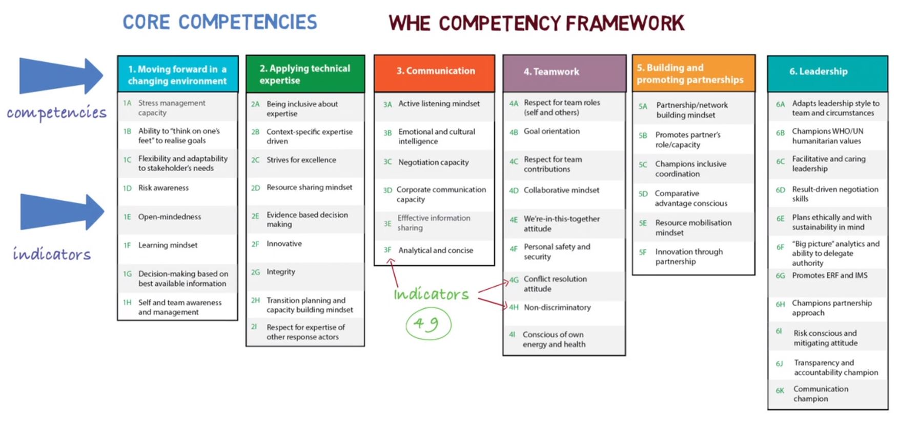
ANNEX G – OSL TRAINING NEED & PLAN for 2020

https://openwho.org/courses/intro-competency
The WHO transformation agenda https://apps.who.int/gb/ebwha/pdf_files/WHA72/A72_48-en.pdf)
https://www.who.int/about/who-we-are/our-values
https://media.ifrc.org/grand_bargain_localisation/
WHO signed Grand Bargain https://interagencystandingcommittee.org/grand-bargain
ERF- https://www.who.int/hac/about/erf/en/
Reference to Incident Management System http://origin.who.int/health-cluster/about/structure/IMS_structure.pdf
The consultation for this strategy has included headquarters, WHO country and regional offices, surge capacity and learning experts within WHE, not solely core OSL staff.
WHE learning Strategy – https://www.who.int/emergencies/publications-resources/training/tools/whe-learning-strategy.pdf?ua=1
Reference to the WHO Competencies Framework. https://www.who.int/employment/WHO_competencies_EN.pdf
https://openwho.org/courses/intro-competency
Annex F – Summary of WHE Competencies and behavioral indicators
Elearning course on WHE Learning Strategy https://openwho.org/courses/intro-competency
Reference to Annex C: OSL learning curricula mapping
Reference to WHE Learning Strategy Companion Document pp 8.
Link to OSL Training Development Toolkit
Reference to the Annex B: Competency Framework for OSL Learning,
Reference the WHO Corporate Framework for Learning and Development (2014 – 2020), the WHO Human Resources Strategy (2014), the WHO e-Learning Policy, and the WHE Learning Strategy (2018).
Reference to the e-PMDS
Reference to WHE Learning Strategy Companion Document pp 8.
Re. WHE Learning Strategy Companion Document pp 8 and OSL Training Development Tool Kit
Reference to the architecture of the OSL field manual with special color for the OPS part.
Reference to Annex F: The Implementation Plan.
Reference to the WHE Learning Strategy, pp. 11. where further details are laid out.
https://openwho.org/courses?channel=response&q=incident
Ref. Output 3.
Reference to Annex D: OSL Learning pathways
Ref to Deployment and briefing process guidance and workflow
OSL is responsible for the technical part of the briefing and debriefing process to collate lessons learned.
Reference to Annex D: OSL Learning Pathways.
Reference to WHE Learning Strategy Companion Document pp 8.
Reference to the guidance at: https://workspace.who.int/sites/whe/cpi/simulationexercise/SitePages/Simulation%20Task%20Team%20Online%20Portal.aspx. Also Simulation Exercise Management: Introduction https://openwho.org/courses/simex Also EOC Training and Exercises being published. https://extranet.who.int/sph/simulation-exercise#parallax-process.
Reference to Annex B: Competencies Framework for OSL.
Reference to WHE Learning Strategy Companion Document pp 8.
Reference to Annex D: OSL Learning Pathways
Reference to Annex C: OSL interpretation of WHO Competencies Framework.
Reference to Annex E: Standards
https://www.who.int/emergencies/publications-resources/training/tools/whe-learning-strategy.pdf?ua=1

